# Procedure:

# STEP 1:-

First of all Download Microstack in your device through which we will install and access OpenStack.

# STEP 2:-

This Command helps Auto-Initialise MicroStack components such as RabbitMQ , MySQL server

,Node Control ,etc.

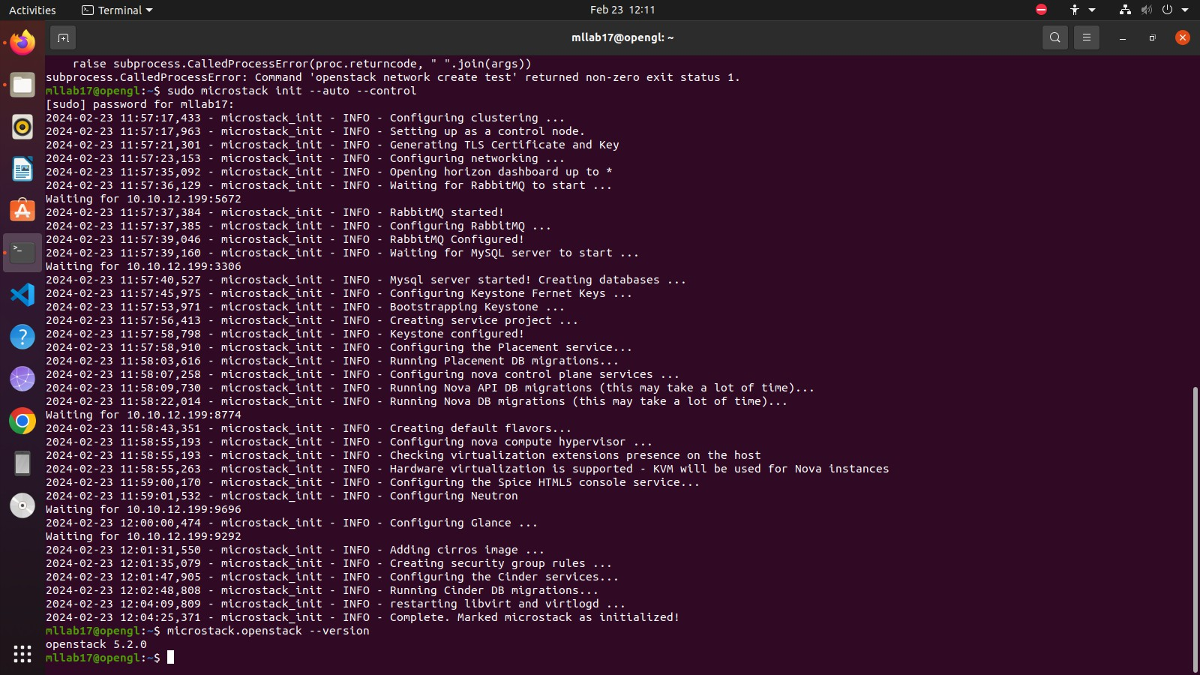

# STEP 3:-

After initialisation of microstack we can check the Openstack version installed using MicroStack and can check the status of openstack image list.

# STEP 4:-

After this step get the Host IP address and open the host home page using the localhost IP address and login using the credentials given in the microstack setting file in the system.

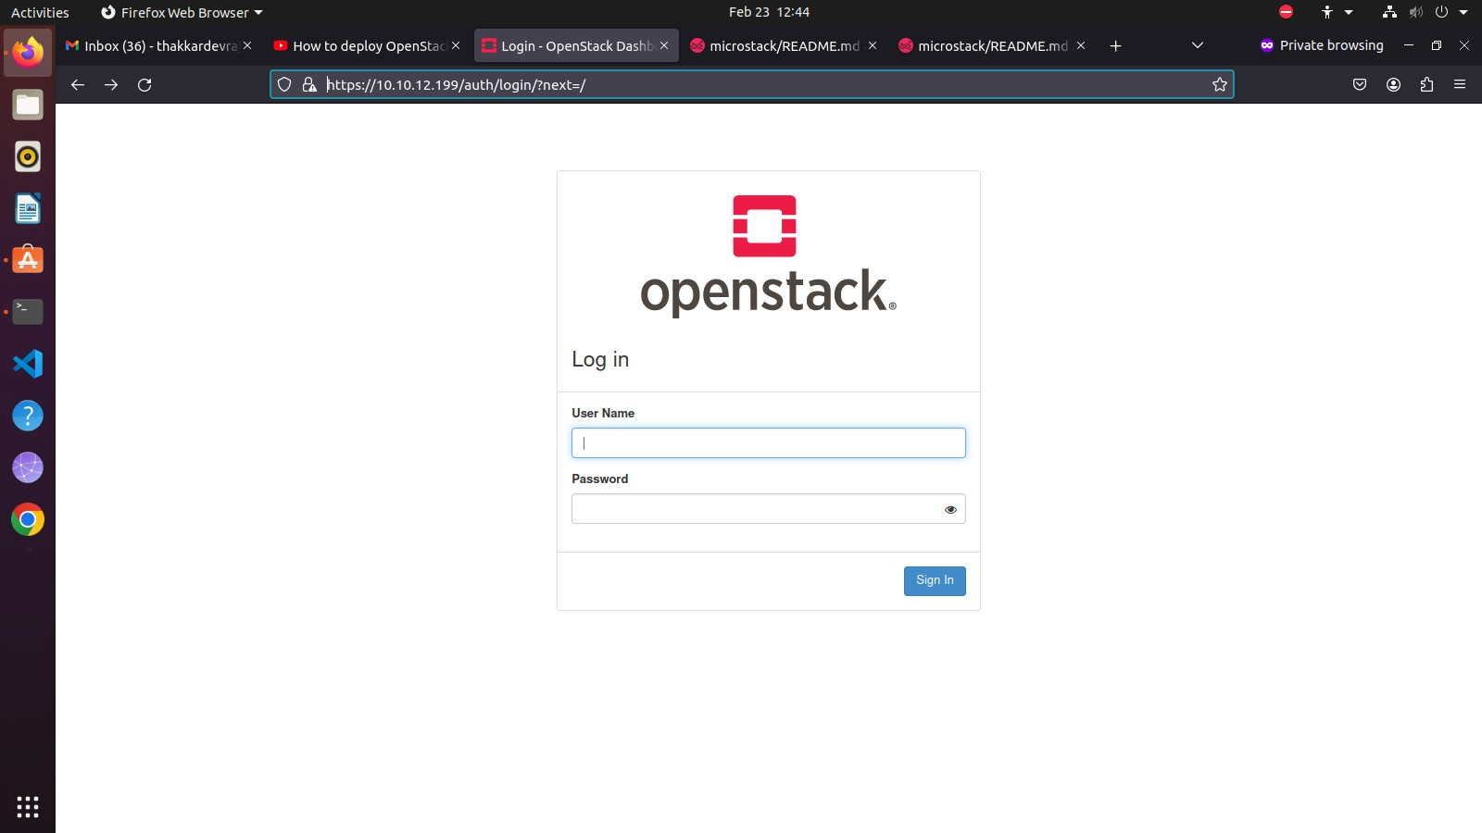

# STEP 5:-

After a successful login we get the Openstack homepage.

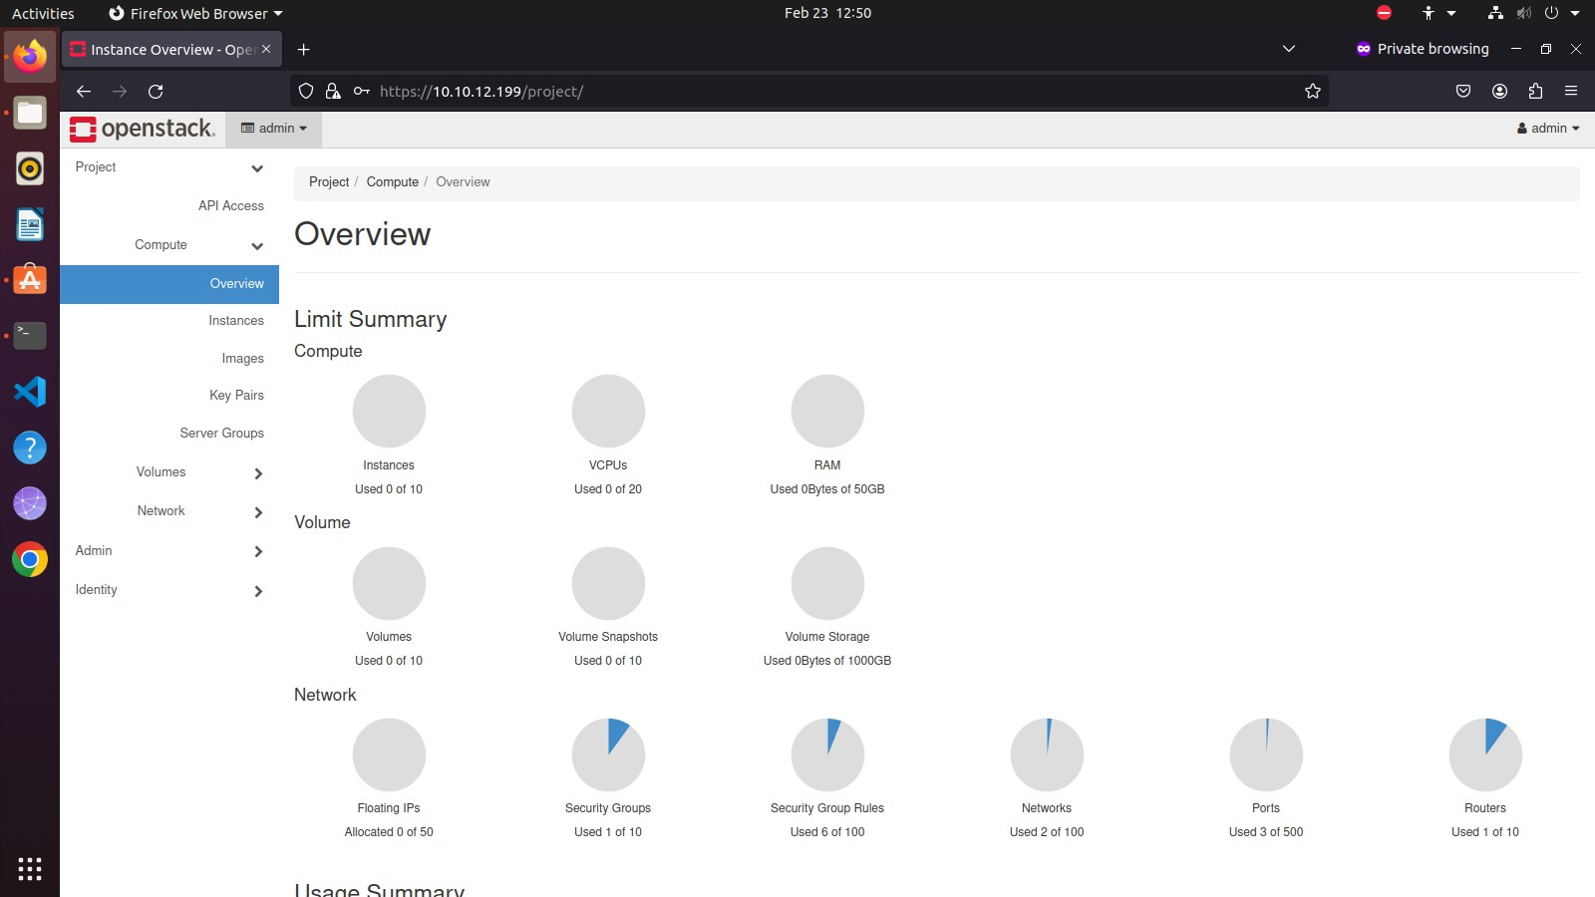Output:

# COMMANDS:-

1. sudo snap install microstack --beta
2. snap list microstack
3. sudo microstack init --auto --control
4. microstack.openstack --version
5. microstack.openstack image list
6. microstack.openstack flavor list
7. to get the IP address use command: hostname -I
8. dashboard URL is https://<ip-address> or

https://<ip-address>/dashboard or https://<ip-address>/horizon

1. username for dashboard is 'admin'
2. below command is for getting dashboard password : sudo snap get microstack config.credentials keystone-password

# CONCLUSION:-

Thus, in this assignment Virtual Machine using Microstack for Infrastructure as a Service and implemented Openstack.